**INTERGRATION DOCUMENT:**

**Part 1: SDG Selection and Problem Definition**

**SDG Selection:**  
For this project, I have chosen **SDG 2: Zero Hunger**. This goal aims to end hunger, achieve food security, improve nutrition, and promote sustainable agriculture.

**Problem Definition:**  
The specific problem identified within SDG 2 is the **uneven distribution of food resources** in urban areas, leading to food insecurity among low-income populations. The goal is to use data to identify areas with the highest need and ensure that food donations are efficiently distributed to those areas.

#### Part 2: Database Design

**ERD (Entity-Relationship Diagram):**  
The database consists of the following entities:

* **Donors:** Entities providing food donations.
* **Food_Items:** Types of food being donated.
* **Distribution_Centers:** Locations where food is distributed.
* **Recipients:** Individuals or groups receiving food donations.
* **Donations:** Records of food donations made by donors.
* **Distribution:** Records of food distribution to recipients.

PART 3: SQL PROGRAMING;

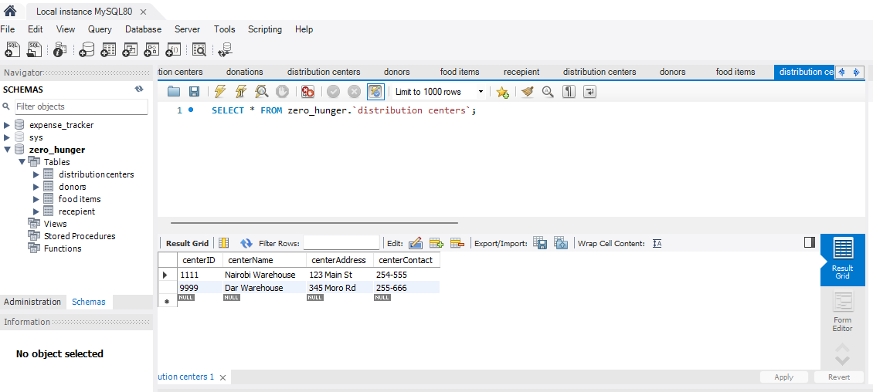

Diagram 1

Using the SELECT clause to retrieval all from distribution centres

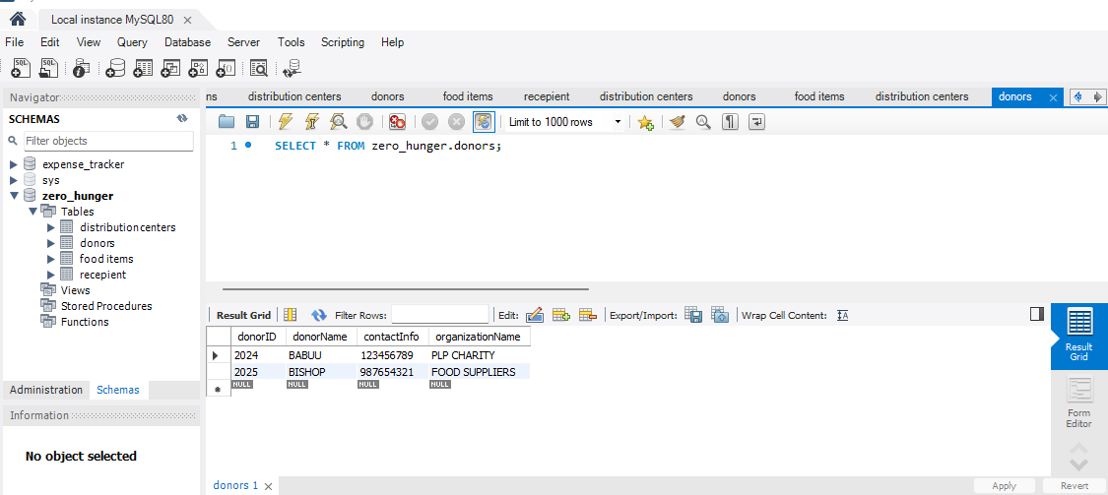

Diagram 2

Using the SELECT clause to retrieval all from donors.

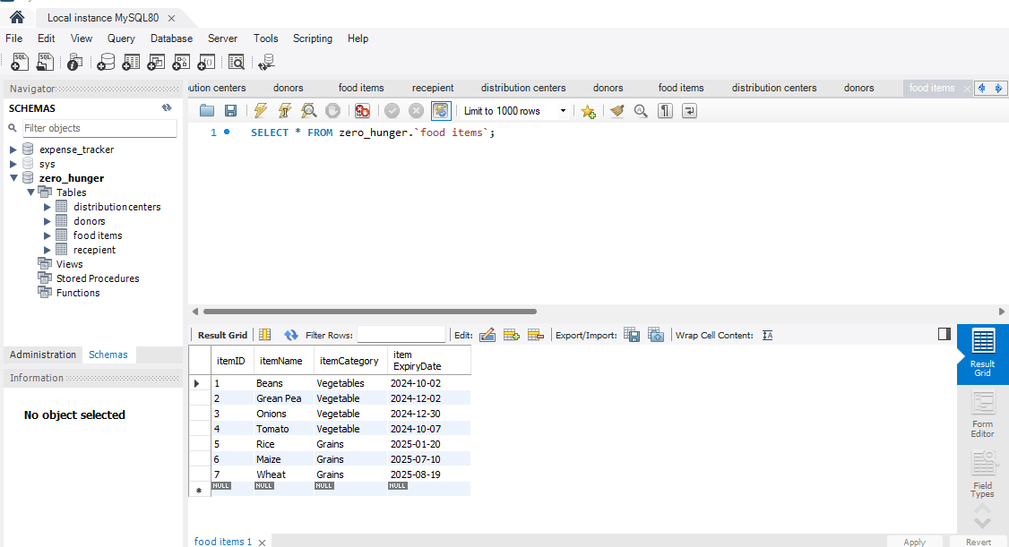

Diagram 3

Using the SELECT clause to retrieval all from food items

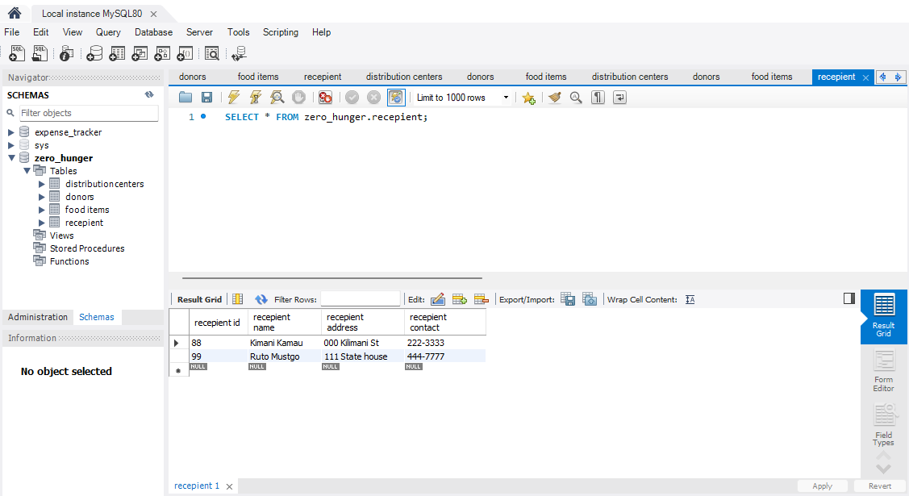

Diagram 4

Using the SELECT clause to retrieval all from recipient.

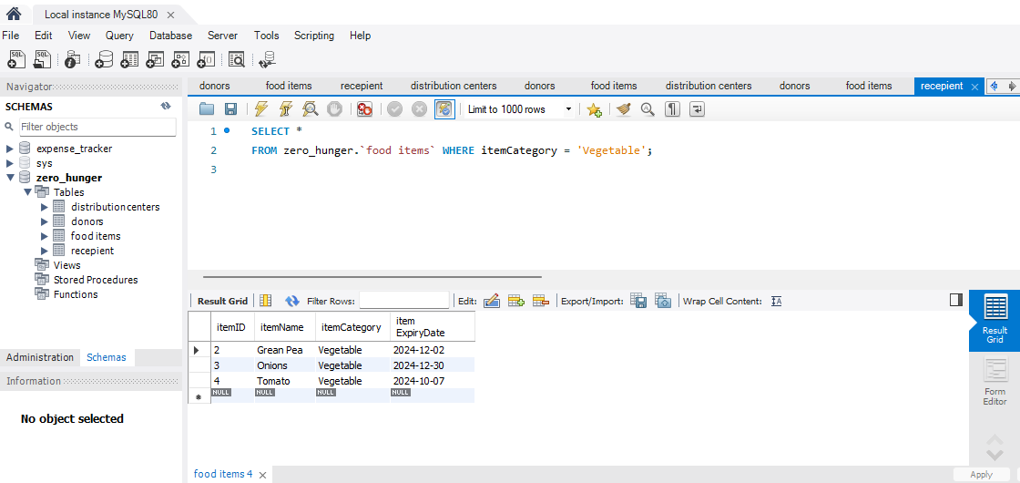

Diagram 5

A query to retrieval all food items that are in vegetable category.

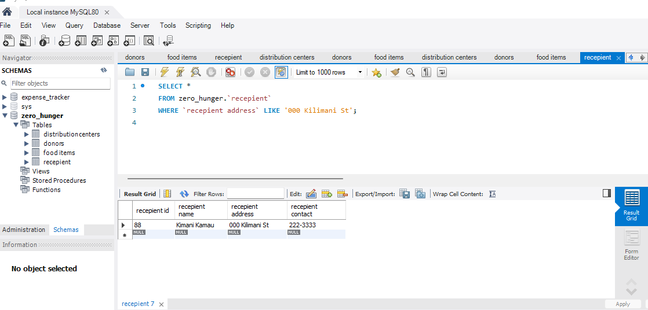

Diagram 6

A query to retrieval all recipient who live in a specific city.

**Part 4: Data Analysis Using Excel**

**Import Data:**

* Export the SQL query results to CSV files.
* Open Microsoft Excel, go to the **Data** tab, and use the **From Text/CSV** option to import the CSV files.

**Analysis:**

* Use pivot tables to analyze the distribution of food by category, center, and recipient.
* Create charts to visualize trends in food donations and distributions over time.

**Dashboard:**

* Develop an interactive Excel dashboard that includes key metrics such as:
  + Total donations by category.
  + Distribution by center and recipient area.
  + Trends in food availability versus need.

PART 5: INTEGRATION AND TESTING;

* Integration; Document the process of importing data into Excel and Ensuring consistency.
* While working on MYSQL workbench, you can navigate to the schema panel on the left side and expand the database that contain the table that you want to export.
* Right click on the table you want to export and select SELECT ROW – LIMIT 100, this will open a new tab displaying the data.
* In the result grind, click on the Export icon and choose to export to CSV, you can also specify the location on your computer where you want the file to be saved.
* You can repeat this for other tables if you want to export multiple tables.
* Now if you want to import the data into excel, open excel into your computer and go to DATA tab.
* Then select from TEXT or CSV under the GET AND TRANSFORM DATA section.
* Browse to the location where you saved the CSV file and select the file you to import.
* After selecting the file Excel will open and preview the data.
* Repeat this process for each of the CSV files you want to import.
* From this stage you can check for the missing data, verify data types, check for duplicates, data validation and cross-check relationships.
* The final stage is to save the data file after ensuring all data are consistent and are correctly formatted.